26.16 Editors - Properties Editor - Bone Properties Tab
25.15 Editors - Properties Editor - Bone Tab 2
Bendy Bones panel 3
Segments 3
Curve X Y Offsets 3
Roll 3
Inherit End Roll 3
Scale 3
Easing 4
Custom Handles 4
Start + End Handle Type 4
Automatic 4
Absolute 4
Relative 4
Tangent 4
Custom Handle 4
Relations panel 5
Parent 5
Relative Parenting 5
Bone Group 5
Connected 5
Local Location 5
Inherit Rotation 5
Inherit Scale 6
Full 6
Fix Shear 6
Aligned 6
Average 6
None 6
None (Legacy) 6
Transform panel 7
Edit Mode 7
Head X, Y Z 7
Tail X, Y Z 7
Roll 7
Lock 7
Pose Mode 7
Location X Y Z 7
Rotation W X Y Z 7
Mode 7
Scale X Y Z 7
Deform panel 8
Deform 8
Envelope Distance 8
Envelope Weight 8
Envelope Multiply 8
Radius Head 8
Tail 8
Inverse Kinematics panel 9
IK stretch 9
Lock IK X Y Z 9
Stiffness X Y Z 9
Limit X 9
Limit Y 9
Limit Z 9
Control Rotation 9
IK Rotation Weight 9
Viewport Display panel 9
Hide 9
Custom Shape 10
Workflow 10
Custom Object 10
Override Transform 10
Scale 10
Scale to Bone Length 10
Wireframe 10

25.15 Editors - Properties Editor - Bone Tab

The bone tab contains bone related settings. The content differs from mode to mode. Left object mode, middle edit mode, right pose mode.
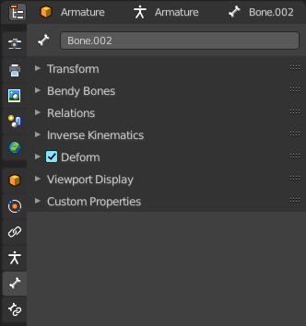
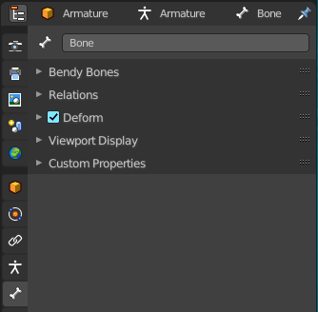
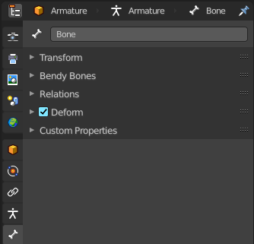

Bendy Bones panel

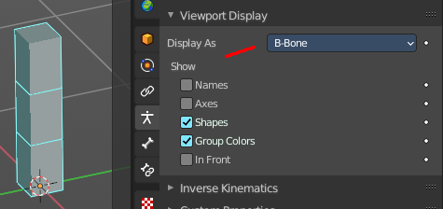
Settings for bendy bones. Bendy bones, also called Bbone, is a special bone mode that allows to divide bones into segments that can be bend and rotated. The “BBone Shape” Keying Set includes all Bendy Bones properties.
You have to activate Bbone in the Object data in the Viewport Display panel. Display as.
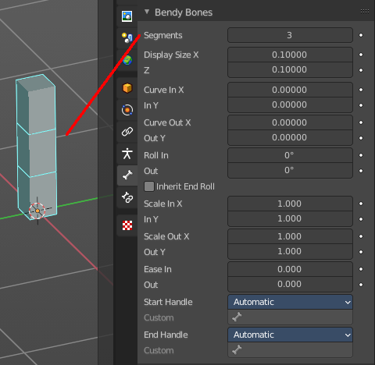
The settings becomes activated when the number of segments is higher than 1.

Segments
The Segments number field allows you to set the number of segments, which the given bone is subdivided into. Segments are small, rigid linked child bones that interpolate between the root and the tip. The higher this setting, the smoother “bends” the bone, but the heavier the pose calculations.

Curve X Y Offsets
Applies offsets to the curve handle positions on the plane perpendicular to the bone’s primary (Y) axis. As a result, the handle moves per axis (XY) further from its original location, causing the curve to bend.

Roll
Roll In, Out
The roll value (or twisting around the main Y axis of the bone) is interpolated per segment, between the start and end roll values. It is applied as a rotational offset on top of the previous rotation.

Inherit End Roll
If enabled, the Roll Out value of the Start Handle bone (connected parent by default) will be implicitly added to the Roll In setting of the current bone.

Scale
Scale In X/Y, Scale Out X/Y
Scaling factor that adjusts the thickness of each segment for the X and Y axes only, i.e. length (Z axis) is not affected. Similar to Roll it is interpolated per segment.

Easing
Ease In, Out
The Ease In/Out number fields, change the “length” of the “auto” Bezier handle to control the “root handle” and “tip handle” of the bone, respectively.
These values are proportional to the default length, which of course automatically varies depending on bone length, angle with the reference handle, and so on.

Custom Handles
B-Bones can use custom bones as their reference bone handles, instead of only using the connected parent/child bones.

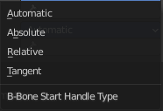
Start + End Handle Type
Specifies the type of the handle from the following choices:

Automatic
The connected parent (or first connected child) of the bone is chosen as the handle. Calculations are done according to the Absolute handle type below.

Absolute
The Bezier handle is controlled by the position of the head (tail) of the handle bone relative to the head (tail) of the current bone. If the handle is also a B-Bone, additional processing is applied to further smooth the transition, assuming that the bones in effect form a chain.

Relative
The Bezier handle is controlled by the offset of the head (tail) of the handle bone from its rest pose. The use of this type is not recommended due to numerical stability issues near zero offset.

Tangent
The Bezier handle is controlled by the orientation of the handle bone, independent of its location.

Custom Handle
For types other than Automatic, a bone to use as handle has to be manually selected. Switching to a custom handle type without selecting a bone can be used to effectively disable the handle.
It is valid for two bones to refer to each other as handles – this correlation is applied in connected chains with Automatic handles.

Relations panel

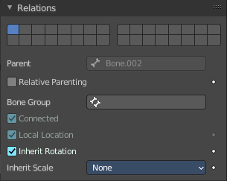
Relation related settings. Note that in Edit mode relative parenting and bone group does not display.
Bone Layers
Allows you to move Bones between Layers by clicking at one of the buttons in the layer element with the needed bone(s) selected.
You can have a bone in several layers. Shift click will add the selected bone(s) to another layer without to remove it from the other layer.
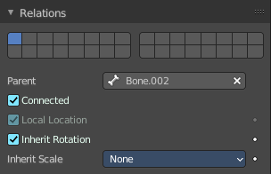
You have to be in Edit Mode or Pose Mode to move bones between layers.

Parent
Usually bones are in a hierarchy with parent and child bones. This parent edit box displays the parent bone. The parent bone can be edited in edit mode.

Relative Parenting
Object children will use relative transform. Like deform.

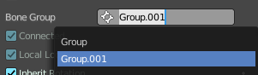
Bone Group
Bones can be in a group. Bone groups are created in the Pose menu in pose mode. The drop down box also allows you to assign the selection to another existing bone group. A bone can be in more than one bone group.

Connected
Set the head of the bone to be connected with its parent root.

Local Location
When disabled, the location transform property is evaluated in the parent bone’s local space, rather than using the bone’s own rest pose local space orientation.

Inherit Rotation
When disabled, this will “break” the rotation relationship to the bone’s parent. This means that the child will keep its rotation in the armature object space when its parent is rotated.

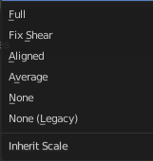
Inherit Scale
Specifies which effects of parent scaling the bone inherits.

Full
The bone inherits all effects of parent scaling and shear.

Fix Shear
Corrects the transformation inherited from the parent to remove shear caused by non-uniform parent scaling and rotation. The process preserves the bone direction, length and volume, and minimally affects roll on average.
If the inherited scale is non-uniform, this does not prevent shear from reappearing due to local rotation of the child bone, or of its children.

Aligned
Parent scaling is inherited as if the child was oriented the same as the parent, always applying parent X scale over child X scale, and so on.
This mode never causes shear and is natural for connected chains like limbs and tentacles.

Average
Inherits a uniform scaling factor that is the total change in the volume of the parent.
This effectively keeps the uniform part of the scaling of the parent, while removing squash and stretch effects. Uniform scaling never causes shear.

None
Ignores all scaling and shear of the parent.

None (Legacy)
Ignores all scaling, provided the parent is not sheared. If it is, there are no guarantees.
This choice replicates the behavior of the old Inherit Scale checkbox, and may be removed in a future release.
These inheriting behaviors propagate along the bones’ hierarchy. So when you scale down a bone, all its descendants are by default scaled down accordingly. However, if you disable one bone’s Inherit Scale or Inherit Rotation property in this “family”, this will break the scaling propagation, i.e. this bone and all its descendants will no longer be affected when you scale one of its ancestors.

Transform panel

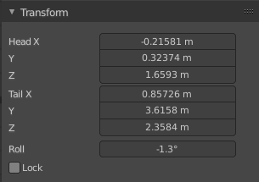
Edit Mode
In Edit mode the bones are created and modified. A bone has a head and a tail. These positions can be adjusted.

Head X, Y Z
The position of the head of the selected bone.

Tail X, Y Z
The position of the head of the selected bone.

Roll
The bone rotation around the head - tail axis.

Lock
Lock the whole bone, the head or the tail from further editing. This depends of what is the current active element.

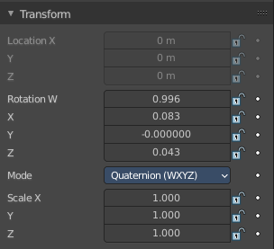
Pose Mode

Location X Y Z
The location of the root bone. Just the root bone can be re-positioned. For all other bones in the hierarchy the edit boxes are greyed out.

Rotation W X Y Z
The rotation of the current bone. With Mode Quaternion you will have the W axis too. With euler angles you will just have X Y and Z axis.

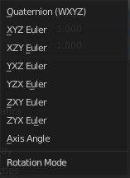
Mode
The rotation mode to use. Euler angles can run into a gimbal lock problem. This means the bone is not longer rotatable. Quaternion rotation avoids gimbal lock.

Scale X Y Z
The scale of the bone.

Deform panel
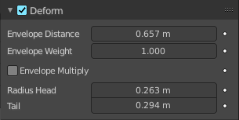

Deform
Enable the bone to deform geometry.
Toggling the checkbox in the panel header off, prevents the bone from deforming the geometry at all, overriding any weights that it might have been assigned before; It mutes its influence.
It also excludes the active bone in the automatic weight calculation when the mesh is parented to the armature using the Armature Deform tool with the “With Automatic Weights” option.

Envelope Distance
Envelope is something like a hull around the bone, which defines an influence area for weighting.
The Distance defines a volume which is the range within the bone has an influence on vertices of the deformed object. The geometry is less and less affected by the bone as it goes away by following a quadratic decay.

Envelope Weight
A bone property, that controls the global influence of the bone over the deformed object, when using the envelopes method.
It is only useful for the parts of geometry that are “shared”, influenced by more than one bone (generally, at the joints…) – a bone with a high weight will have more influence on the result than one with a low weight… Note that when set to 0.0, it has the same effect as disabling the Deform option.

Envelope Multiply
When deforming bone, multiply effects of vertex group weights with Envelope influence.

Radius Head
Set the radius for the head of envelope bones. Inside this volume, the geometry if fully affected by the bone.

Tail
Set the radius for the tail of envelope bones. Inside this volume, the geometry if fully affected by the bone.

Inverse Kinematics panel

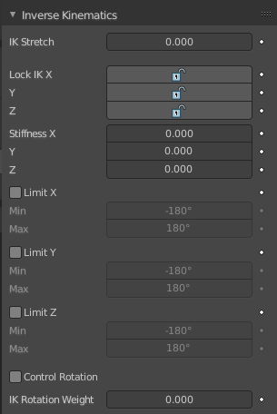
Settings for inverse kinematics. Pose mode only.

IK stretch
Allow scaling of the bone for IK.

Lock IK X Y Z
Lock the single axis for IK.

Stiffness X Y Z
Add a stiffness around the axis.

Limit X
Limit movement around the X axis.

Limit Y
Limit movement around the X axis.

Limit Z
Limit movement around the X axis.

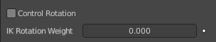
Control Rotation
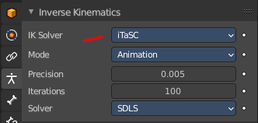
When you use Inverse Kinematics with the iTaSC solver in the object data properties in the Inverse Kinematics panel, then you will reveal this checkbox.
Apply channel rotation as IK constraint.

IK Rotation Weight
Weight of rotation constraint for IK.

Viewport Display panel

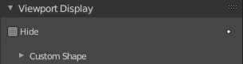
Hide
Hides the selected bone in the viewport.

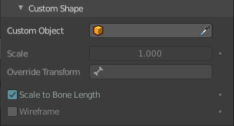
Custom Shape
Use a custom object to be displayed as the bone in Object and Pose mode.

Workflow
Switch to Pose Mode
Select the relevant bone by clicking on it.
Go to the Display panel Custom Shape field and select an object in the scene that you want to use as a display object.

Custom Object
The object that defines the custom shape of the selected bone.

Override Transform
Bone that defines the display transform of the custom shape.

Scale
Additional scaling factor to apply to the custom shape.

Scale to Bone Length
Option not to use bones length, so that changes in Edit Mode don’t resize the custom shape.

Wireframe
Display bone in wire frame mode regardless of the viewport display mode.

